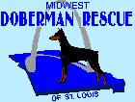 | The Dobie Digest
April 1, 2008 | Volume 1, Issue 1
In This Issue  - Welcome to The Dobie Digest  - Midwest Doberman Rescue Needs Your Help!  - Upcoming Adoption Events  - Look Who’s Going Home!  - Mosquito Season is Upon Us  - April’s Featured Doberman  - Does Your Dobie Need 15 Minutes of Fame?  - Visit Our Website  - Thank You!  - Donations  Adoptable Dobies Links  Alex  Brody  Cowboy  Dallas  Gina  Kody  Kulani  Rebel  Ruckus  Upcoming Events  4/5/2008 – Adoption Event at Petco  5/4/2008 – Annual Bully Bash  5/24/2008 – Dobie & Boxer BBQ  5/30/2008 – Dog Days of Summer  Doberman 411  Doberman Rescue FAQ's  Frequently Asked Questions About Doberman Rescue  10 Good Reasons for Adopting an Older Dog  Think puppies are the best way to bring a dog into the family? Think again.  Can You Afford a Doberman?  Dobies are often relinquished to rescue due to financial concerns. Be realistic about the cost of dobie owernship.  Health Problems in the Doberman  Every breed has its own health concerns. Educate yourself with those common among Dobermans.  Visit Our Website  Make a Donation  Thanks for Reading The Dobie Digest  See you in May…  Debbie Long,  Publisher  Bri Long,  Editor-In-Chief  Debbie McReynolds, Director - MWDR | Welcome to The Dobie Digest  Welcome to The Dobie Digest, our latest and greatest addition to the quarterly Midwest Doberman Rescue Newsletter. The email version of The Dobie Digest will be sent out each month as well as saved on our website. We hope to provide some helpful information about Doberman ownership, Success Stories, and featured Dobermans for adoption.  To be added to the email distribution list for this newsletter, please click here to contact us via email.  Midwest Doberman Rescue Needs Your Help!  What can I do, you ask? Foster a Doberman! Our foster homes right now are each filled to the gills with Dobermans. When we have no room, we may have to turn away Dobies that need our help. We’ve been fortunate enough to have help from other Dobie Rescue groups, but this is just a short-term solution. The St. Louis area needs more MWDR foster homes to be successful in helping all the homeless Dobermans in our region.  What is foster care? Foster care is temporary nurturing in a household environment. We do not wish to kennel a Doberman in transition. Whenever possible, when a Doberman is homeless, we try to find a temporary loving home where the Doberman can be cared for, evaluated, and trained while waiting for a permanent placement. We frequently are without foster homes, and must ask relinquishing families to be patient while we help find a permanent home for the Doberman. Lack of foster care is a hardship when we must take a Doberman from a shelter.  Who is eligible to be a foster family? Foster care is ideal for those who have had experience with Dobermans, but perhaps do not wish to commit to a permanent placement. Or, perhaps, a foster family already has a dog, but has the facilities to care for more than one dog for a time. This can be a very rewarding experience.  What is involved with foster care? Provide a loving household environment and food for a homeless Doberman. If you cannot afford to feed an extra dog, we can assist. MWDR takes care of all veterinary expenses. Bring your foster dog to our adoption events to better his or her chances at getting adopted. That’s all there is to it! We make every attempt to match a Dobie’s personality with your lifestyle. If you’re a jogger, we have high energy Dobes. If you’re a couch potato, we have couch potato dogs, too! If you already have a Dobie and think you can’t possibly handle another, keep in mind that dogs are pack animals. A pair of dogs may occupy each other’s time and need less of yours.  Why should I foster? Because without fail, when we place one homeless Dobmerman, another one (or two, or five) need our help. Knowing you helped save a dog’s life is a very rewarding experience. When you foster one dog, you are really helping two – the animal you are fostering, and another animal we are able to take because you have freed up one of our homes.  OK, I’m convinced! How do I sign up? Contact us via email at MWDR. Request an application to be a foster parent. Upon approval (we are looking for responsible pet owners with a fenced yard), we will provide you with a Doberman and tell you all about his or her personality to make the transition to your home as smooth as possible. You will paid in doberkisses!  Upcoming Adoption Events  April 5, 2008 – Adoption Event – 11am-2pm at Petco in St. Peters  Come on by to see our adoptable Dobies!  May 4, 2008 – Bully Bash – 10am-4pm at Dusable Park, St. Charles  This annual event is designed to educate the public about various bully breeds. There will be several rescue groups and vendors attending, including MWDR. Bring your dog (on a 6ft leash or less) and your family – there are games for kids, games for dogs, and merchandise for purchase. Bring that extra cash you have lying around – proceeds go to various not-for-profit rescue organizations.  May 24, 2008 – Fundraiser BBQ – 11am-5pm at Frontier IGA, St. Charles  Have lunch or dinner with us at our annual fundraiser barbeque! Menus in the past have included chicken, hot dogs, bratwurst and pork steak dinners with coleslaw, baked beans, chips, cookies, soda and water. All proceeds go to Midwest Doberman Rescue and Boxer Rescue to help cover vet bills and other expenses for rescue dogs in our programs. Due to health regulations, this is a dog-free event.  May 30, 2008 – Dog Days of Summer – 11am-5pm on Main St, St. Charles  R. T. Weilers is hosting their 3rd Annual Dog Days of Summer on Main Festival. There will be 25 pet related business/adoption agencies and shelters. This event will be in the 100-200 blocks of Main Street. There will be a Beach Wear Competition at 1 pm. Dress your dog in his/her favorite beach attire and let them strut their stuff. There is a dog and owner limbo competition at 5:00. There will be live bands from 12:00 - 5:00. And there will be a Kiddie Korner with activities for the human kids. Please stop by and see some of our great adoptable Dobermans.  Look Who’s Going Home!  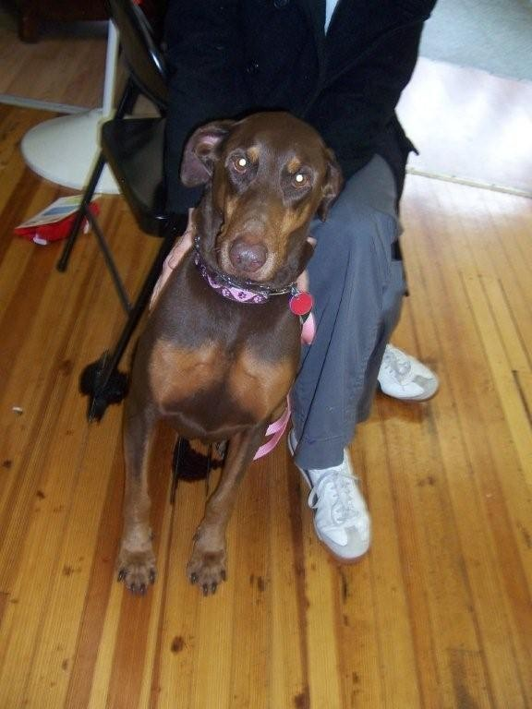  Miss Diva found her forever home at our Easter Adoption Event at Airedale Antics. Diva certainly lives up to her name – a goddess of a Dobergirl, she is very regal in nature. Diva came to us from Springfield, MO. At eight years young, she is a prime example of why you should consider adopting a senior. Good luck in your forever home, Diva, and we hope to hear from you!  Mosquito Season is Upon Us  Treatment for Heartworm Disease involves a 2 or 3-dose series of injections and strict cage rest for 4-6 weeks. The injection sites are typically sore and staying calm is hard on many dogs who want to run and play like dogs do.  The good news is, Heartworm Disease is easily preventable with a monthly dose of heartworm preventative such as Heartguard or Interceptor. If your dog is not currently on a heartworm preventative, have your vet do a heartworm test and, if negative, prescribe the right heartworm preventative for your pet.  We rescue Dobermans every month with this disease and it is frustrating watching a dog go through a painful treatment for something that is so easily prevented. It is expensive to treat Heartworm Disease and the treatment itself is hard on the dog. Be sure to have your dog tested for this deadly disease annually and keep them on a monthly heartworm preventative year round.    April’s Featured Doberman - Katie  Katie came to MWDR on February 15, 2008. Katie’s first family gave her up due to urinating in the house. Katie’s second owner surrendered her to us for being aggressive with her male Dobie. Katie came into rescue a little depressed, which is not unusual. We thought she was really missing her family so we moved her out of a foster home with a lot of dogs into one where there were kids and only one other Dobe. She was still a little sad. Eventually her depression turned into complete lethargy, refusal to eat, excessive water intake, occasional vomiting and walking into things. We were told by a Vet Tech that knew Katie that she is a happy-go-lucky dog with the energy level of a Jack Russell Terrier. Unfortunately, that is not the Katie we have come to know.  Blood tests show Katie has increased liver functions and a urinary tract infection. X-rays show a small liver, often indicative of scarring on the liver. We are currently awaiting the results of a test for Leptospirosis, a contagious canine disease that is not typically common in our area but which Katie was exposed to and not vaccinated against. However, our vet thinks that most likely Katie has a chronic liver disease called Chronic Active Heptatitis and/or Copper Storage Disease. The prognosis for either of these diseases is not favorable with the clinical symptoms that two year old Katie has.  Katie is not currently available for adoption. She is being made comfortable in her foster home with a special diet, supplements and medication while we wait for her test results. The next step is to have an ultrasound-guided biopsy of the liver, an expensive but necessary test to determine the cause of Katie’s liver problems and plan the very best course of action. Remember to give your Dobie extra hugs tonight and be thankful that he or she is healthy. In the meantime, know that Katie is being treated like the Princess that she is and maybe the extra love will go a long way in helping her feel better.  Does Your Dobie Need 15 Minutes of Fame?  Have a Success Story about one of our rescue dobies? Or a funny dobie story you want to share? Submit your story and/or a picture of your dobie via email.  Visit Our Website  www.MidwestDobermanRescueStL.org  Thank You!  Thank you for reading the first electronic edition of The Dobie Digest. We look forward to hearing from you for ways to improve this newsletter.  Click here to be added to our email distribution list  Click here to send in your favorite dobie stories  Click here to send feedback (be nice!)  Click here to be removed from our email distribution list  Debbie Long, Publisher  Bri Long, Editor-In-Chief  Debbie McReynolds, Director-MWDR  Donations  Midwest Doberman Rescue of St. Louis depends on private donations from generous donors like you. Your contributions are fully tax deductible and all donations go directly to impact the health and lives of the Dobermans in need.  For your convenience, we are now able to accept donations via PayPal. On the MWDR website, click the PayPal button from any page (on the left, under our site menu) and you will be directed to their site to make an easy online donation.  Donations can also be sent to:  Midwest Doberman Rescue of St. Louis  PO Box 406  St. Charles, MO 63302-0406
  Along with the warm weather we are all looking forward to, mosquito season is quickly approaching. Why don’t dogs like mosquitoes? Because they can transmit Heartworm Disease.
  Heartworm Disease is a common parasitic condition that can be transmitted to dogs, cats and the occasional ferret by the bite of a mosquito. The disease, left untreated, can progress through four classes and often is fatal.
  Dogs who are heartworm positive may have symptoms such as coughing or exercise intolerance, but many dogs have no symptoms at all.

